Nama : Maldi Ramadhan

NIM : 1918088

Kelas : C

Data Citra Kue Nastar

|  |  |  |  |
| --- | --- | --- | --- |
| NO | Gambar | Luas Area | Perimeter |
| 1 |  | 13699 | 370.323 |
| 2 |  | 18681.8 | 356.578 |
| 3 |  | 13341.4 | 399.32 |
| 4 |  | 14558.6 | 371.483 |
| 5 |  | 16075.5 | 375.844 |
| 6 |  | 16877.8 | 370.644 |
| 7 |  | 16111 | 374.732 |
| 8 |  | 14810.6 | 370.421 |
| 9 |  | 13939 | 370.579 |
| 10 |  | 16262.5 | 366.931 |
| 11 |  | 20231.5 | 335.6 |
| 12 |  | 16575.1 | 364.069 |
| 13 |  | 19161.9 | 338.321 |
| 14 |  | 17503.8 | 352.26 |
| 15 |  | 21036.4 | 329.775 |
| 16 |  | 20267.6 | 328.388 |
| 17 |  | 19198 | 346.164 |
| 18 |  | 18512.3 | 335.475 |
| 19 |  | 19341.1 | 337.322 |
| 20 |  | 19017.4 | 355.499 |

Design GUI :

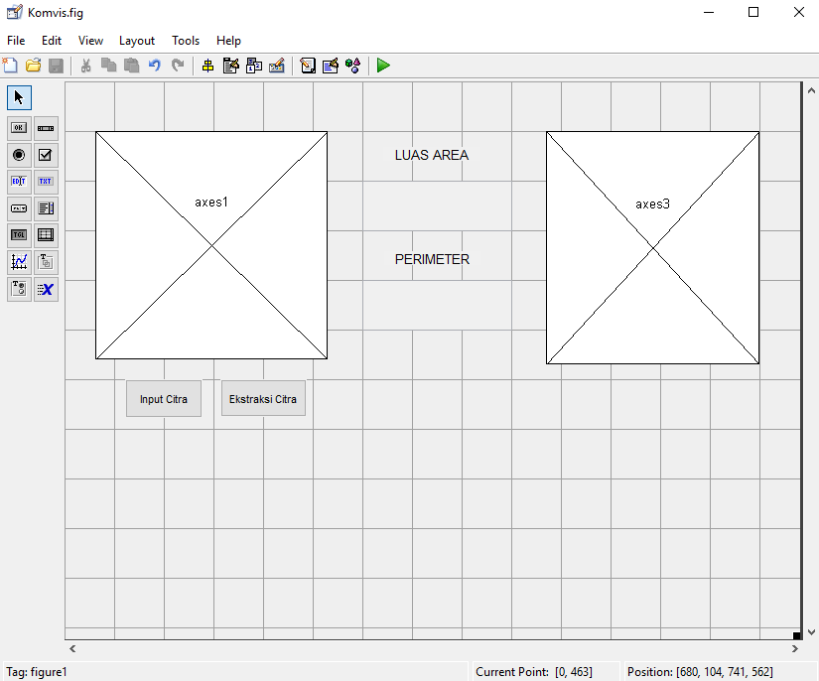

*Source Code* :

|  |
| --- |
| function pushbutton1_Callback(hObject, eventdata, handles)  open = guidata(gcbo);  [namafile]=uigetfile({'*.jpeg;*.jpg;*.bmp;*.png'},'openimage');  I=imread(namafile);  set(open.figure1,'currentAxes',open.axes1);  set(imagesc(I));colormap('gray');  set(open.axes1,'Userdata',I);  function pushbutton2_Callback(hObject, eventdata, handles)  open=guidata(gcbo);  x = get(open.axes1, 'userdata');  y = rgb2gray(x);  level = graythresh(y);  z = im2bw(y,level);  set(open.figure1,'CurrentAxes',open.axes3);  set(imagesc(z));colormap('gray');  set(open.axes3,'Userdata',z);  area = bwarea(z);  perim = bwperim(z);  perimeter = sum (sqrt(sum(perim,2)));  set(handles.edit1,'String',area);  set(handles.edit2,'String',perimeter); |

Contoh Hasil Ekstraksi

